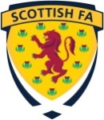

Match Incidents Form
Competition:
Match: |  |  | v
Club ID's: (SYFA Only) |  |  | v
Date:
Match Officials | Name |  |  | SFA Reg. No.
Referee:
Assistant Referee 1:
Assistant Referee 2:
Fourth Official:
Report Author:
Designation: | Referee / Assistant Referee / Fourth Official
Time of Incident:
Type your report here:

